**Lab 04 Task**



**Name Hammad Arshad**

**Roll no SU92-BSAIM-F23-030**

**Section BSAI-4A**

**Subject PAI (LAB)**

**N-Queen problem:**

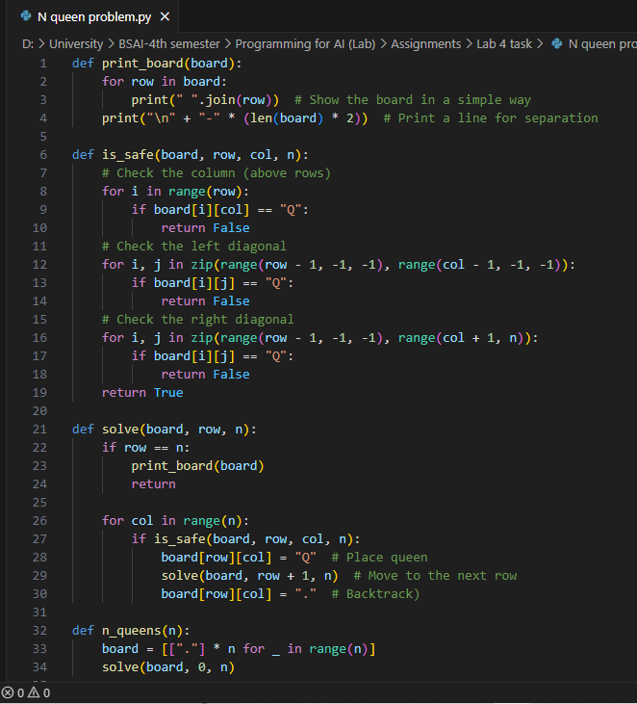

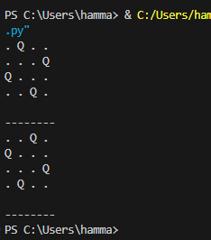

This is the **N-Queens Problem**, where we have to place **N queens on an N×N chessboard** so that no two queens attack each other.

**How the Code Works:**

1. We **create an empty board** using dots (.) to represent empty spaces.
2. We place one **queen (Q) per row** in a way that:
   * No two queens are in the **same column**.
   * No two queens are in the **same diagonal**.
3. The program **tries all possible positions** to find the correct arrangement.
   * If a queen is **placed safely**, it moves to the **next row**.
   * If no position is safe, it **removes the queen (backtracking)** and tries another column.
4. Whenever a solution is found, **it prints the board**.

**Why This Code Works:**

* It **checks all possible placements** using recursion.
* It **removes wrong placements** using backtracking.
* It **only prints correct solutions** where no queens attack each other.

**Accuracy & Output:**

The output shows different ways to place **N queens** safely. For **N = 4**, we get two correct solutions. Each one follows the rules, meaning the solution is **100% correct**.